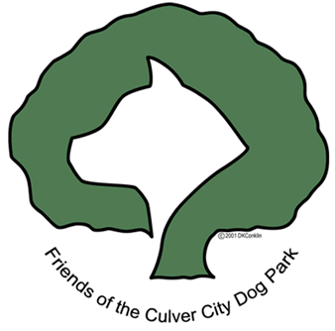
P. O. Box 4129
Culver City CA 90231-4129
310-397-2112-Fax Email: info@culvercitydogpark.org
www.culvercitydogpark.org

Dear Supporter:

Help us make the dream of an off-leash dog park in Culver City a reality by supporting our Boneyard Bash 3 fundraising dinner on October 15, 2005.

Who: Friends of the Culver City Dog Park

What: Boneyard Bash Dinner/Live Auction/Silent Auction/Cash Giveaway
$65.00 per person

When: Saturday, October 15, 2005 - 6pm Silent Auction; 7:30pm Dinner

Where: Wyndham Hotel,
6333 Bristol Parkway, Culver City

Why: To raise funds and support for a fenced in, off-leash dog park in Culver City to be
located in Culver City Park.

How: By attending the event, purchasing an ad, donating auction items, volunteering,
buying raffle tickets

Deadlines: For Auction Items: October 7, 2005
For Ads: September 30, 2005

Program Ads: 1/8 page - $25; 1/4 page - $50; 1/2 page - $100; full page - $200; inside back
cover - $300; inside front cover - $400

To donate Silent & Live Auction items, contact Laura Stuart at 310-390-4757 or 310-487-5214 or email at stuartlauraj@hotmail.com

To place an ad, or for program book information, contact Mike Whitaker at 310-365-1514 or email whitakerm@comcast.net

Mail your ads (camera ready), gift certificates, checks, dinner reservations, and donations to: Friends of the Culver City Dog Park, P O Box 4129, Culver City CA 90231-4129.

We appreciate your support.

For further information on Friends of the Culver City Dog Park, please visit our website at
www.culvercitydogpark.org or email us at info@culvercitydogpark.org - or phone Vicki Daly Redholtz, Chair at 310-390-9114

